Insert your name, centre number and candidate number into the header above.
Save this evidence document as evidence_ followed by your centre number_ candidate number. For example: evidence_ zz999_9999.doc
Screenshots or program listings must be copied into appropriate cells in the following tables.
Examiners must be able to read the contents including any screenshots without the use of a magnifying glass. Answers that are not readable or missing will not be awarded any marks.
Save this evidence document at regular intervals, for example, every 10 minutes.
Question 1
Part 1(a)
def ReadData():
Colours=[""]*45
Count=0
try:
File= open("Data.txt")
for Line in File:
if Count<45:
Colours[Count]= Line.strip()
Count += 1
File.close()
except:
print("No file found")
return Colours

Part 1(b)(i)
def FormatArray(DataArray):
OutputText=""
for x in range(0,45):
OutputText= OutputText+ DataArray[x] + " "
return OutputText

Part 1(b)(ii)
Colours= ReadData() #string array
print(FormatArray(Colours))

Part 1(b)(iii)
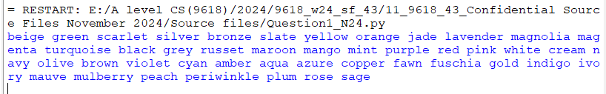

Part 1(c)
def ComapareStrings(First,Second):
Count= 0
while True:
if First[Count] < Second[Count]:
return 1
elif First[Count] > Second[Count]:
return 2
else:
Count = Count + 1

Part 1(d)(i)
def Bubble(DataArray):
ArrayLength= len(DataArray)
for x in range(ArrayLength-1):
for y in range(0,ArrayLength-x-1):
Result= ComapareStrings(DataArray[y],DataArray[y+1])
if Result == 2:
DataArray[y],DataArray[y+1]=DataArray[y+1],DataArray[y]
return DataArray

Part 1(d)(ii)
BubbleSorted= Bubble(Colours)
print(FormatArray(BubbleSorted))

Part 1(d)(iii)
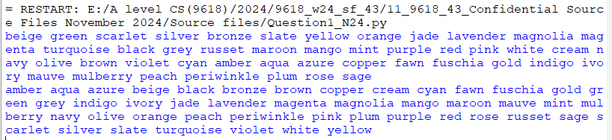

Question 2
Part 2(a)(i)
class Horse:
def __init__(self,PName,PMaxFenceHeight,PPercentageSuccess):
self.__Name=PName #String
self.__MaxFenceHeight=PMaxFenceHeight #Integer
self.__PercentageSuccess=PPercentageSuccess #Integer

Part 2(a)(ii)
def GetName(self):
return self.__Name
def GetMaxFenceHeight(self):
return self.__MaxFenceHeight

Part 2(b)(i)
Horses=[]
Horses.append(Horse("Beauty",150,72))
Horses.append(Horse("Jet",160,65))
print(Horses[0].GetName())
print(Horses[1].GetName())

Part 2(b)(ii)
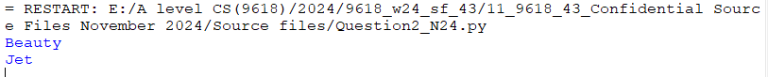

Part 2(c)(i)
class Fence:
def __init__(self,PHeight,PRisk):
self.__Height = PHeight #integer
self.__Risk = PRisk #integer
def GetHeight(self):
return self.__Height
def GetRisk(self):
return self.__Risk

Part 2(c)(ii)
Course=[]
for x in range(0,4):
Valid= False
while Valid== False:
Height= int(input("Enter the height in cm"))
if (Height>= 70 and Height<= 180):
Valid= True
Valid= False
while Valid== False:
Risk= int(input("Enter the risk between 1 (easy) and 5 (hard)"))
if (Risk>= 1 and Risk<= 5):
Valid= True
Course.append(Fence(Height,Risk))

Part 2(d)
def Success(self,Height,Risk):
if Height> self.__MaxFenceHeight:
return self.__PercentageSuccess*0.2
else:
if Risk == 1:
return self.__PercentageSuccess
elif Risk == 2:
return self.__PercentageSuccess*0.9
elif Risk == 3:
return self.__PercentageSuccess*0.8
elif Risk == 4:
return self.__PercentageSuccess*0.7
else:
return self.__PercentageSuccess*0.6

Part 2(e)(i)
for y in range(0,2):
for x in range(0,4):
Chance=Horses[y].Success(Course[x].GetHeight(),Course[x].GetRisk())
print("The horse ",Horses[y].GetName()," at fence ",x+1," has a ",Chance,"% chance of success")

Part 2(e)(ii)
AverageSuccess=[]
for y in range(0,2):
Total=0
for x in range(0,4):
Chance=Horses[y].Success(Course[x].GetHeight(),Course[x].GetRisk())
print("The horse ",Horses[y].GetName()," at fence ",x+1," has a ",Chance,"% chance of success")
Total= Total+ Chance
Average= Total/4
AverageSuccess.append(Average)
print("The horse ",Horses[y].GetName()," has an average ",Average,"% chance of jumping over all four fences")
Highest=AverageSuccess[0]
Winner=0
for x in range(1,2):
if Highest<AverageSuccess[x]:
Winner=x
Highest=AverageSuccess[x]
print(Horses[Winner].GetName()," has the highest average chance of success")

Part 2(e)(iii)
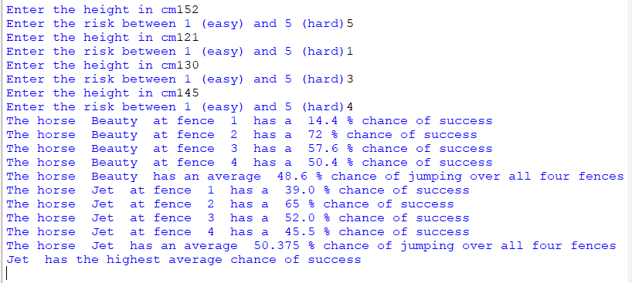

Question 3
Part 3(a)
LinkedList=[]#global
FirstNode=-1
FirstEmpty=0
for x in range(0,19):
LinkedList.append([-1,x+1])
LinkedList.append([-1,-1])

Part 3(b)
def InsertData():
global LinkedList
global FirstNode
global FirstEmpty
for _ in range(5):
if FirstEmpty != -1:
nextEmpty= LinkedList[FirstEmpty][1]
LinkedList[FirstEmpty][0]= int(input("Value: "))
LinkedList[FirstEmpty][1]= FirstNode
FirstNode= FirstEmpty
FirstEmpty= nextEmpty

Part 3(c)(i)
def OutputLinkedList():
global LinkedList
global FirstNode
global FirstEmpty
CurrentPointer= FirstNode
Flag=True
while Flag:
print(LinkedList[CurrentPointer][0])
CurrentPointer= LinkedList[CurrentPointer][1]
if CurrentPointer == -1:
Flag=False

Part 3(c)(ii)
InsertData()
OutputLinkedList()

Part 3(c)(iii)
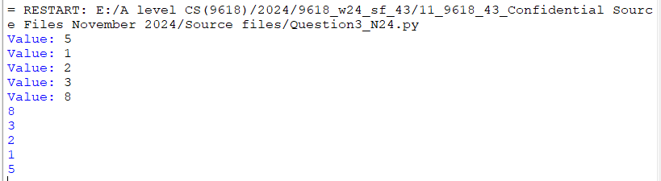

Part 3(d)(i)
def RemoveData(ItemToRemove):
global LinkedList
global FirstNode
global FirstEmpty
if LinkedList[FirstNode][0] == ItemToRemove:
NewFirst= LinkedList[FirstNode][1]
LinkedList[FirstNode][1]= FirstEmpty
FirstEmpty= FirstNode
FirstNode= NewFirst
else:
if FirstNode != -1:
CurrentPointer= FirstNode
PreviousNode= -1
while (ItemToRemove != LinkedList[CurrentPointer][0] and CurrentPointer != -1):
PreviousNode = CurrentPointer
CurrentPointer = LinkedList[CurrentPointer][1]
if ItemToRemove == LinkedList[CurrentPointer][0]:
LinkedList[PreviousNode][1]=LinkedList[CurrentPointer][1]
LinkedList[CurrentPointer][0]= -1
LinkedList[CurrentPointer][1]= FirstEmpty
FirstEmpty= CurrentPointer

Part 3(d)(ii)
LinkedList=[]
FirstNode=-1
FirstEmpty=0
for x in range(0,19):
LinkedList.append([-1,x+1])
LinkedList.append([-1,-1])
InsertData()
OutputLinkedList()
RemoveData(5)
print("After")
OutputLinkedList()

Part 3(d)(iii)
